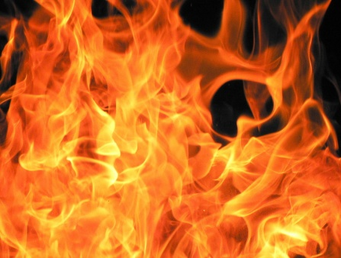
Name___________________________
Date____________________________
Chapter 6 Quiz The Outsiders

Spell the word “FIRE” by choosing from the provided questions. Answer your four selected questions in a different color font and save carefully in your journal on your H:drive.

F Why did Cherry decide to help the Greasers?
F What decision did Johnny reach? Why did he think this way?

I Why did Ponyboy and Johnny go into the burning church? What would you have done?
I What happened to Johnny, Ponyboy, and Dally?

R When did Ponyboy realize that Darry loved him?
R How did Ponyboy feel about his life now that he understood Darry?

E An event like the fire in the church would be reported by local newspapers and television stations. Imagine you are a reporter covering this story, and write an article for your newspaper.

