Nothing Gold Can Stay
By Robert Frost

Nature’s first green is gold,
Her hardest hue to hold.
Her early leaf’s a flower;
But only so an hour.
Then leaf subsides to leaf.
So Eden sank to grief,
So dawn goes down to day.
Nothing gold can stay.
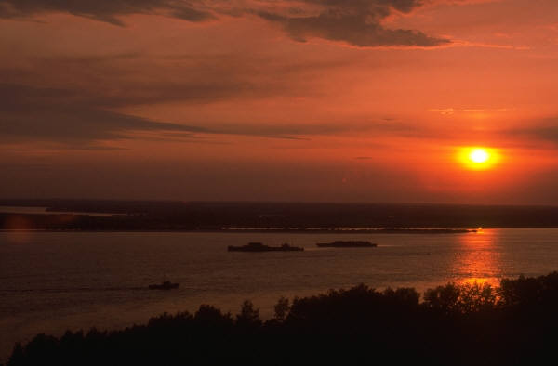
1. Turn to page 68 of The Outsiders, and look at the bottom where it says, “one morning…” Reread to “By the fifth day” on page 70. Why does Ponyboy recite the poem “Nothing Gold Can Stay” to Johnny?

2. What does “nature’s first green is gold” mean? Think about it! First, when does nature’s first green appear (what time of year)? Second, what does it mean when something is gold or golden? Okay, now put it all together. What does Frost mean by describing the nature’s first green ( ) as gold?

3. Why is the gold in nature so hard to hold?

4. Frost is using nature’s first green, or ____________, as a symbol for something else. He is really referring to the ___________ of your lifetime. What time period in your life could he be referring to?

5. There are three disappointing events described in this poem. List them.
a.
b.
c.

6. What is the tone of the poem? (ex: happy, sad, silly, funny, etc.) Explain.

7. Describe the rhyme pattern of this poem. In other words, look at the last word of each line and describe the pattern of how the poem rhymes.

